Would you/would you not recommend the book? Why?

Would recommend
Would not recommend

Why?
_____________________________________________________________
_____________________________________________________________

Rating:
Who would this book be suitable for? Age/interests

Age:
456789101112

Interest:
SportAnimalsHistoryStoriesCountries
PoetryCookingFunnySad For Boys
For GirlsToysActivitiesPicturesOther
What is the book about?

Book Review
Book Illustration

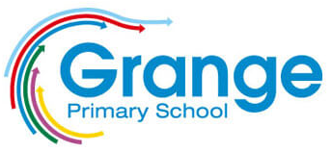
Book review by: ___________________________________________

Title: _______________________________________________________

Author: ____________________________________________________

Non fiction Fiction

